An Introductory Proposal

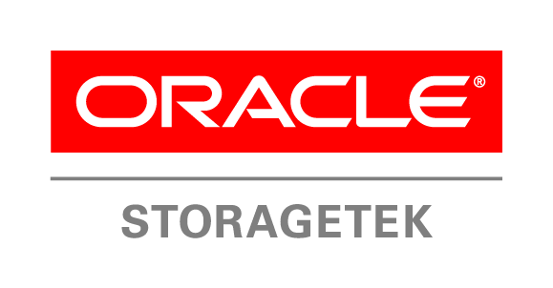

*Economical --- Proactive --- Designed for Cloud*

A Proposal for:

<Company Name> Oracle Sales Representative: <Name>

<Customer’s Title> E-mail: <E-mail address>

<Company Address> Mobile: XXX-XXX-XXXX

# Executive Summary

Archiving and data protection can be the difference between success and failure as your organization tries to digitize and monetize intellectual property, discover what makes your customers tick, or meet regulatory requirements. Protecting and accessing key assets should be simple and reliable, empowering your business and accelerating productivity across your organization. Yet your business is facing three key issues that require more efficiency, higher performance, and greater automation from your archiving and data protection solutions:

* Unstoppable growth of both unstructured and structured data
* “Save everything forever” business mandates
* Limited budgets and headcount growth

Many IT suppliers are making your job ever more complex by offering either under-performing and expensive point products or higher-performing yet complex and difficult to manage multi-vendor solutions. Oracle’s StorageTek solutions for archiving, compliance, data protection, and digital preservation help you address these issues with the intelligence, efficiency and economics that characterize Oracle’s StorageTek portfolio.

Oracle’s StorageTek data protection and archiving solutions leverage over 30 years of experience and expertise in data storage and information lifecycle management. StorageTek solutions help you gain control over soaring data growth, meet compliance requirements, guard against data loss and corruption, and preserve valuable business assets and intellectual property. With the world’s highest capacity and highest performing storage solutions, including the world’s first exabyte storage system, Oracle’s StorageTek solutions for data protection and information lifecycle management enable you to dramatically increase the overall efficiency of your storage and lower your total cost of ownership, without compromising on business agility or jeopardizing compliance with corporate governance and/or regulatory mandates.

Whether built on an all-Oracle software platform or supported by our large community of third-party ISVs, Oracle’s StorageTek solutions for archiving and data protection solve at-scale data retention, protection and management problems for customers of all sizes.

We believe that your organization can benefit from the intelligence, efficiency, and economics of Oracle StorageTek solutions by making them an integral part of your IT infrastructure. Please take a few minutes to read the following pages and see why a wide variety of enterprises including some of the world’s biggest internet and cloud companies rely on tested and proven data storage solutions from Oracle StorageTek.

Attached please find a sample configuration which we can use to start a discussion of your business requirements and IT needs. I’ll follow up with a phone call to set up a meeting.

I look forward to meeting you in person.

Sincerely,

# Why You Should Consider Oracle For Your Archiving and Data Protection Needs

With Oracle, you have a clear choice when making your next storage purchasing decision. In today’s IT environment, you are bombarded with multiple technologies and multiple solutions all vying to resolve your data protection and long-term data retention concerns. There is much confusion about which technologies and which solutions are best for business continuity, disaster recovery and archiving. Oracle provides a broad portfolio of data protection technologies for information lifecycle management, business continuity and disaster recovery, as well as solutions addressing the unique requirements of long term data retention and preservation.

With over 30 years of industry leadership in data protection, you can rely on Oracle as your trusted advisor for both data protection and long-term data retention. For example, did you know that Oracle’s solutions that incorporate Oracle’s StorageTek tape storage can store data for 10-30 years as opposed to 5-7 years for popular disk based solutions, scale to petabytes and even exabytes, help reduce datacenter footprint, significantly lower datacenter energy costs, all while reducing total cost of ownership?

Regardless of what problem you are trying to solve, Oracle has the right solution for you. Oracle’s StorageTek portfolio of tape storage solutions includes multiple tape drive technologies, modular and highly scalable tape libraries and a full suite of software for backup & restore, archive management, and archive health monitoring & reporting. Furthermore, since Oracle is one of the few vendors that develop their own flash, disk and tape storage products we can offer integrated tiered storage solutions with automated, policy-based data movement. Research by the Clipper Group has shown that disk plus tape tiered storage architectures can be as much as 87 percent lower in TCO than all-disk solutions for long-term archiving.

## StorageTek Tape Automation

The Oracle StorageTek award winning line of modular tape libraries includes the entry-to-midsize SL150, midrange-to-enterprise SL4000 and enterprise-scale SL8500.

### StorageTek SL150 Modular Tape LibrarySL150

Oracle's StorageTek SL150 modular tape library is the ideal backup and archive solution for growing businesses and branch offices that value ease-of-use, seamless scalability and low-cost. Built from Oracle software and StorageTek library technology, the StorageTek SL150 modular tape library saves both time and money, setting the new standard for entry tape automation.

The StorageTek SL150 modular tape library allows you to start small and scale capacity by up to 10x – to 3.6PB of uncompressed archive and backup capacity using industry standard LTO-8 tape technology. The SL150 offers higher density, lower and lower cost scaling than comparable products, is simple to manage and operate, and can be directly expanded by the customer without a service call.

### ****SL4000****

The StorageTek SL4000 is a midrange library that offers uncompromising scalability, connectivity, availability, and choice with up to 108PB of uncompressed capacity. The StorageTek SL4000 modular library system enables you to scale from 200 to just over 9,000 cartridge slots and from 1 to 56 tape drives in a high-density footprint that grows linearly in a rack environment. Choose between high-capacity LTO8 solutions and Oracle’s enterprise-grade, high capacity Oracle StorageTek T10000 tape technology.

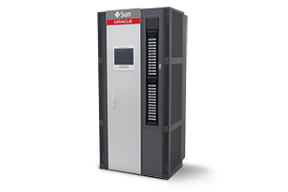The StorageTek SL4000 modular library system is designed for the most demanding enterprise environments. Non-disruptive scalability and serviceability, redundant robotics, and optional dual-control path technology ensure that you always have access to business-critical data and media assets.

Featuring Oracle’s Real Time Growth capability, the StorageTek SL4000 enables you to install physical capacity in advance and tap into it when you need it. Grow your archives at your own pace and pay only for the capacity you need, when you need it, and with no physical parts to install.

### StorageTek SL8500**S**L8500****

The StorageTek SL8500 modular library system is the world’s most scalable tape library, accommodating growth up to 1.1 exabytes (or 3.0 exabytes with 2.5x compression), making it an extremely powerful solution for intelligent archiving of big data, high definition media assets, social media or healthcare records and images.

Not only is the SL8500 the world’s most scalable tape library, it is also the fastest. To meet the high-performance needs of your enterprise datacenter, each StorageTek SL8500 library is equipped with four or eight robots and up to 640 tape drives working in parallel for high throughput and availability. And, like the SL3000, the SL8500 offers complete component redundancy and serviceability to support 24x7 operations.

## StorageTek Tape Drive Technology

Oracle provides choice and flexibility to choose the tape technology that best meets your organizations objectives. We offer both enterprise grade, high capacity StorageTek T10000 tape technology and midrange LTO tape technology for all our data protection and archiving solutions.

### StorageTek LTO

Oracle offers industry-standard StorageTek LTO8 tape drives for all StorageTek libraries and in single drive desktop or rack mount form factors. These eighth-generation technologies offer up to 12TB per cartridge of uncompressed capacity, 360MB/second of throughput, and powerful on-drive error correction and verification capabilities so you can scale critical archiving capabilities with astounding ease and economics.

### StorageTek T10000D Tape DriveStorageTek T10000D

The Oracle StorageTek T10000D stores up to 8.5 TBs per data cartridge (21.25 TB with 2.5:1 compression) and an uncompressed data transfer rate of 252 MB/s (over 700MB/s with compression) with on-drive data verification..

StorageTek Data Management Software

From proactive health monitoring to automated data tiering, Oracle’s StorageTek data management software makes managing your data easier than ever before.

### StorageTek Hierarchical Storage Manager

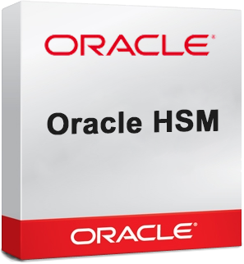Putting the right information on the right storage can save money over time. Oracle’s StorageTek Hierarchical Storage Manager software actively manages data on multiple storage tiers and in multiple locations to let companies exploit the substantial acquisition and operational cost differences between flash, disk, and tape devices.

Hierarchical Storage Manager provides an abstraction layer between applications and underlying storage tiers so that applications remain unaware of the physical location of data. As information is written, it is automatically and transparently placed on the most cost-effective storage according to retention and retrieval policies you assign. This lets you align data storage and archiving costs with your business priorities.

### StorageTek Tape Analytics

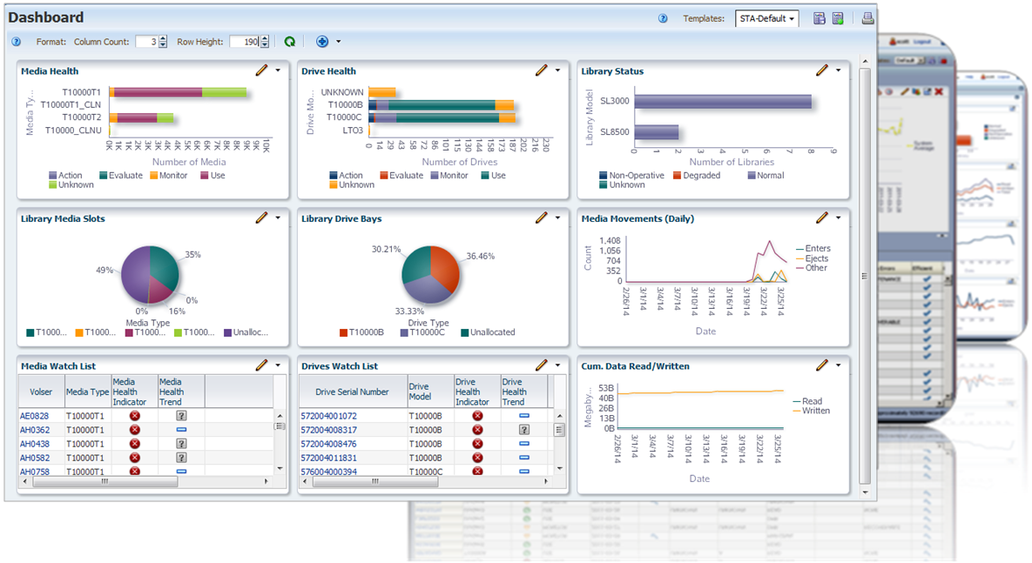StorageTek Tape Analytics (STA) is powerful analytics software that provides customers with deep insight into their global tape operations. STA goes far beyond reporting a single red, yellow, or green indicator. Rather, STA provides deep insight into more than 100 different drive, media, and library functions and empowers storage administrators to continuously monitor the health of their archive solution and make proactive decisions about their environment prior to device failures.

## Engage the Storage Experts

Oracle Advanced Customer Services helps you address storage challenges by delivering installation, configuration, optimization and other tailored services. Oracle service professionals help you achieve the highest levels of system performance and availability with diagnostic and monitoring tools that help anticipate, identify and remediate any potential issues. From tape library installation services to the design and implementation of key management encryption systems, Oracle service experts help you realize more value from your storage infrastructure - with less disruption to your business.

# What Customers Are Saying About Oracle StorageTek:

#### [Rhodri James, Technology Director, Gorilla TV Ltd](https://www.oracle.com/uk/customers/gorilla-1-storagetek.html)

“We were looking to expand our linear tape open digital tape library and migrate to the latest generation. Oracle’s StorageTek SL150 was the most flexible and dense solution. This, coupled with Oracle’s 24/7 support made it the right decision for our business critical operations.”

#### [James Gardner, Director, Department of Post](https://www.oracle.com/nz/customers/dept-of-post-1-storagetek.html)

“We selected Oracle’s StorageTek SL150 modular tape library over Dell and HP for its ease of use, simple upgrade process, and low-cost expandability to support our rapid growth. We now create archives 3x faster, have enabled remote upload for our clients, and increased staff productivity.”

#### [Bob Maynard, Storage Team Leader, UK Met Office](https://www.oracle.com/uk/customers/met-1-storage-tek.html)

“With Oracle’s modular tape library system, we now have a cost-effective and future-proof storage solution, with the performance and capacity we need to deliver improved weather forecasting and climate predictions for the public, government, and businesses.”

#### [Dinesh Singh, Chief Technology Officer, New Delhi Television Ltd.](https://www.oracle.com/in/customers/new-delhi-tv-1-div-archive.html)

“We selected Oracle DIVArchive and Oracle’s StorageTek over Evitt and Mastech because Oracle is simply the best in the content storage management market. We have ensured content security and increased workflow efficiency by 40%, enabling us to retrieve content 4x faster and reduce tape costs by 98%.”

#### [Tsujii Takahiro, IT Group Leader and Research Associate, Information Initiative Center, Nara Institute of Science and Technology](https://www.oracle.com/apac/customers/naist-7-storage.html)

“By using a highly scalable and energy-efficient Oracle hierarchical storage solution, we drastically reduced data-center operating costs by US$5.3 Million, stored up to 2.7x more research data, and enhanced collaboration for international research development activities.”

#### [Francis Dequenne, Principal Systems Analyst, Data Handling System, ECMWF](http://www.oracle.com/us/corporate/press/2008766)

"The European Centre for Medium-range Weather Forecasts (ECMWF) requires a cost-effective and scalable storage solution to archive its large repository of meteorological data - currently 50PB, expected to grow by 45 percent each year. The bulk of this data is saved on StorageTek T10000 media, and is retrieved by researchers across Europe and the world, resulting in over 15,000 tape mounts per day. The data is vital to the success of your organization, hence the reliability of the media and tape drives is paramount. Now we look forward to installing T10000D drives, which will help minimize our costs while allowing us to meet the extreme demands of our tape storage environment.”

# For More Information

**Visit:** [www.oracle.com/goto/tape](http://www.oracle.com/goto/tape)